Forgotten Realms
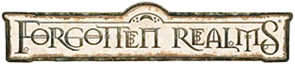
The focus of the Forgotten Realms setting is the continent of Faerûn, part of the fictional world of Abeir-Toril, usually called simply Toril, an Earth-like planet with many real-world influences. Unlike Earth, the lands of the Forgotten Realms are not all ruled by the human race: the planet Abeir-Toril is shared by humans, dwarves, elves, goblins, orcs, and other peoples and creatures. Technologically, the world of the Forgotten Realms is not nearly as advanced as that of Earth; in this respect, it resembles the pre-industrial Earth of the 13th or 14th century. However, the presence of magic provides an additional element of power to the societies. There are several nation states and many independent cities, with loose alliances being formed for defense or conquest. Trade is performed by ship or horse-drawn vehicle, and manufacturing is based upon cottage industry.

North West
The northwestern part of Faerûn is a region of wilderness, difficult winter weather, orc hordes, and barbarian tribes. It is a mostly untamed region that lies between the large Anauroch desert in the east and the expansive Sea of Swords to the west.

The High Forest (Forgotten Realms)
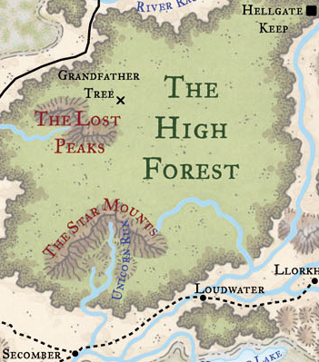
This is a vast region of old forest growth that stretches from the Nether Mountains range in the north to near the settlement of Secomber in the south, and along the Dessarin Valley along the western face. The eastern border of the High Forest follows the course of the Delimbiyr river, which flows southward from the Nether Mountains then bends to the southwest to pass north of the High Moor. The forest up to 500 miles across, and is considered the greatest forest in Faerûn, covering nearly 20% of the lands of what is called the "Savage Frontier."
What lies within this deep forest is somewhat of a mystery, and few travel there to explore its depths. The more notable locations in the forest include the majestic Star Mounts—providing the headwaters of the Unicorn Run and the Heartblood River; the Lost Peaks in the northwest that form the headwaters of the Dessarin river; the fabled Grandfather tree; the Dire Woods in the east; as well as many dungeons, ruins, abandoned settlements, and mysterious locales.
Among the known inhabitants of the woods are the aarakocra among the Star Mounts, centaurs, dragons, drow, a few elves and humans, gnomes, korred, gnolls, orcs, pegasi, pixies, satyrs, treants, and unicorns. The few humans who dwell here are generally rangers, druids, or adventurers used to surviving in wild environments. Trade with the outside world is infrequent, as the forest is self-sufficient and its resources provide for the inhabitants.
The Druid Ogian, a Chosen of Meilikki has gained a reputation of great prestige across the western heartlands for his reclamation and subsequent occupation of the Stronghold of the Nine in the High Forest. He is a known ally of Silverymoon, the Caelcilern, and the Druids of Talltrees among others and is believed to know firsthand many of the secrets of the ancient forest.
In the past the forest formed part of the elven kingdom of Eaerlann. However, most of the elves have since departed to join the retreat to Evermeet. The forest is no longer ruled by any one group, but instead contains many forces and groups in competition. The most powerful of these are the treants led by Turlang. However, wood elves are growing in numbers and seek to reestablish the kingdom of Eaerlann. Standing in their way, however, are innumerable tribes of orcs, gnolls, and an alliance of demon-spawned elves from Hellgate Keep.
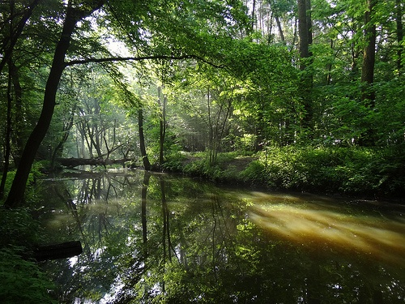
The southern slopes of the legendary Star Mounts contain the Endless Caverns, which are said to be home to dragons and to connect to the Underdark. To the south of the caverns is the "Stronghold of the Nine," an abandoned dwarven site now apparently claimed by elves. To the east of the mounts and south of the Heart Blood river, is the ruined Netherese city of Karse. The region of forest within the wide bend of the Heart Blood river is called the Dire Wood, where a great massacre once took place. Strange supernatural phenomena originate from this place, and it is home to two liches by the name of Wulgreth.
At the northern end of the High Forest is an area called Turlang's Wood, a place where the forest is continuing to expand thanks to the tending of a band of treants. At the northeast tip of the forest, their efforts have sealed off Hellgate Keep, the site of a deadly battle with a powerful demon named Kanyrr Vhok.

Endless Caverns
The Endless Caverns are a series of deep-reaching cavern and tunnel complexes located to the south of the Star Mounts. Inside the Endless Caverns live many powerful and dangerous creatures, such as Grimnoshtasdrano, the Riddling Dragon, and the lich Aumvor The Undying .

Fortune
You have come seeking your fortune in a small town called Fortune. The town has grown up rather suddenly, after a band of adventurers found a new entrance into the Endless Caverns. The story goes that the first levels have been cleared, but there are still huge finds being made in the lower depths.
One rainy day, you travel north on a road that parallels a branch of the Unicorn Run. The road is muddy and filled with ruts.
Fortune turns out to be smaller than you expected.
A wooden barricade surrounds a tent city, and a half-built stone structure which is dedicated to Tymora. Several workmen can be seen working on the temple.
